

NAME: BISMA FATIMA
CLASS: CS A
ROLL NO: F24605036
COURSE: ARTIFICIAL INTELLIGENCE
COURSE CODE: CS-281
LECTURER: SIR IJLAL HAIDER

LAB TASK 01

In Lab Tasks
Task 1
Write a Python program that:
- Creates an empty list.
- Repeatedly asks the user to enter an integer and stores it in the list.
- Stops taking input when the user types "no".
- After collecting all numbers in the list, check whether all numbers are prime.
- Print the result:
- If all numbers are prime 🡪 "All numbers in the list are prime."
- Otherwise 🡪 "Not all numbers are prime.”
PROGRAM
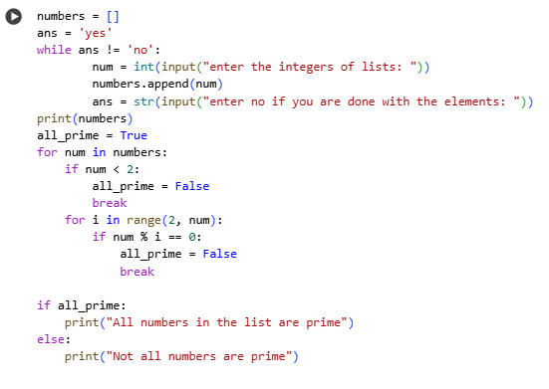

OUTPUT
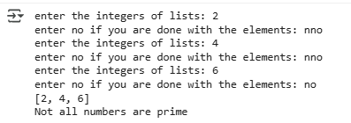
Task 2
Create a Python program that stores the names of students and their marks in a dictionary.
- The program should display the list of available student names.
- The user will enter a student’s name, and the program should display that student’s marks.
- If the name does not exist in the dictionary, the program should display a message saying “Student not found in the record.”

PROGRAM
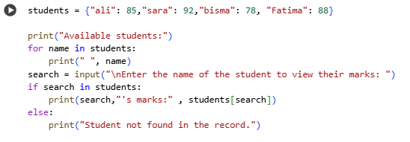
OUTPUT
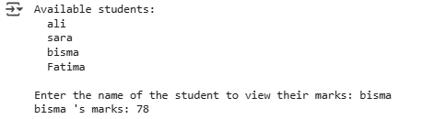
Post Lab Tasks
Task 1
Write a Python program that:
- Accepts a string input from the user.
- Removes all the vowels (a, e, i, o, u, both uppercase and lowercase) from the string.
- Prints the resulting string after removing vowels.

PROGRAM
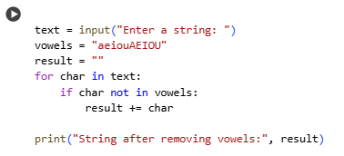
OUTPUT
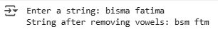
Task 2
Create a tuple of numbers.
- Check if all numbers in the tuple are positive.
- If yes, print "All numbers are positive", else print "Some numbers are negative"

PROGRAM
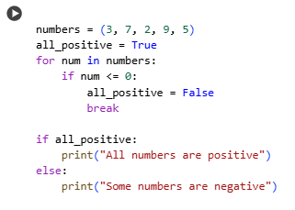
OUTPUT

